1. Install Git from <https://git-scm.com/downloads>
2. Either Install Java 11 or Java 17 because as of today Jenkins only support these two versions.
3. Create Environment Variables For Java and Jenkins in User and System Variable.
4. Install Apache Tomcat Server from <https://tomcat.apache.org/download-90.cgi>  
     
   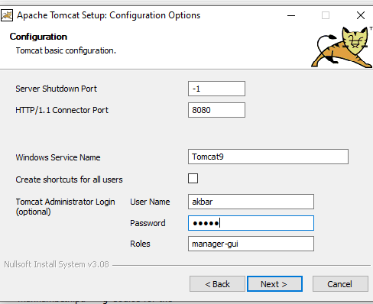
5. As we are installing Jenkins On Tomcat Server , make sure to download Jenkins war file.
6. Go to http://localhost:8080/ This will open Apache Tomcat.
7. You can see Root , Docs and Manager file.
8. Restart the System.
9. Again Restart the Apache Tomcat Server and Copy the Jenkins .war file in the web app folder of Apache Tomcat.

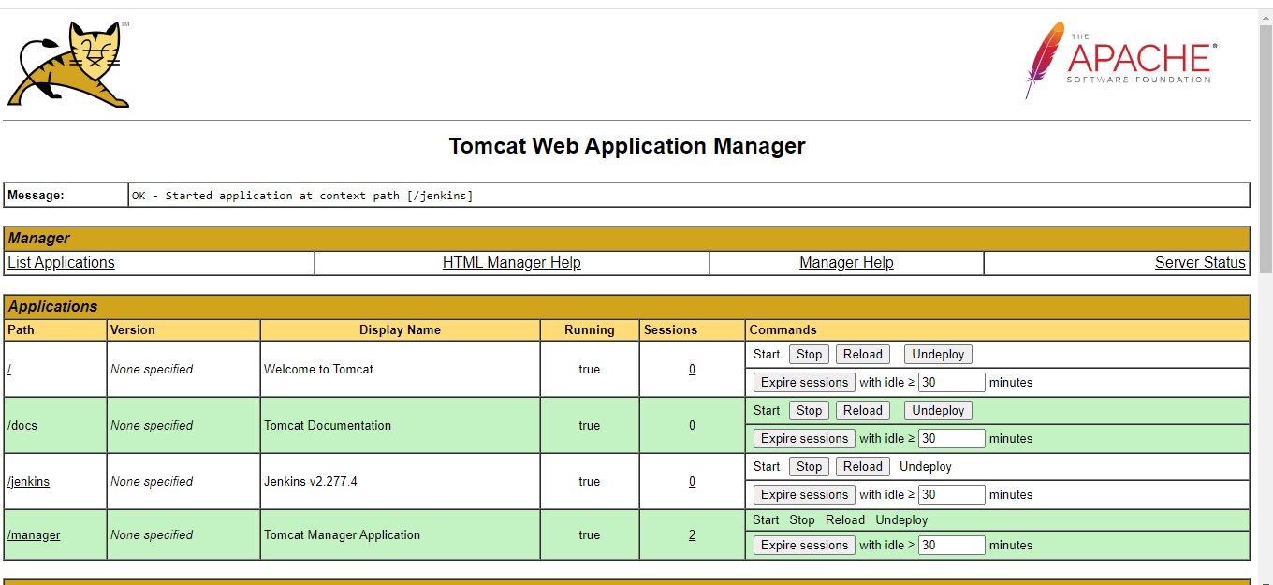

1. Unlock Jenkins , you can find the password in the initialadminpassword of Jenkins.  
     
     
   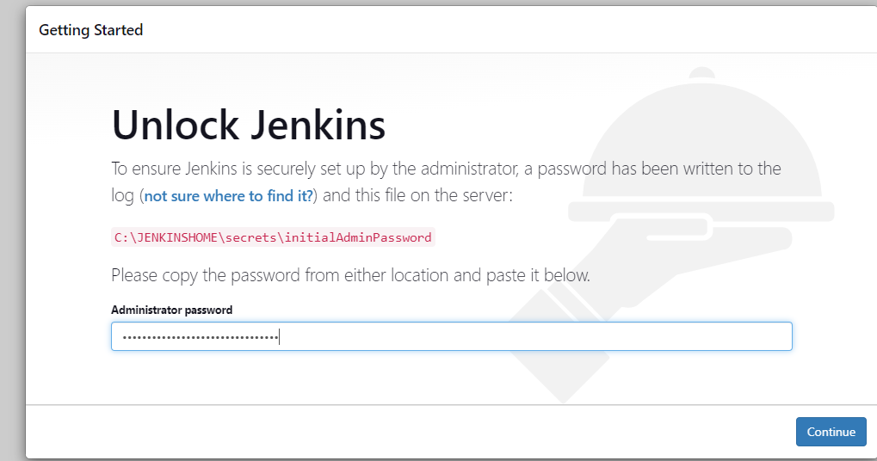
2. For Build , I have used Apache Ant instead of Maven.
3. Install Apache Ant and Provide the System Variable.
4. We need to restart the system again.
5. We need to Clone a Github project , we can use git clone command.

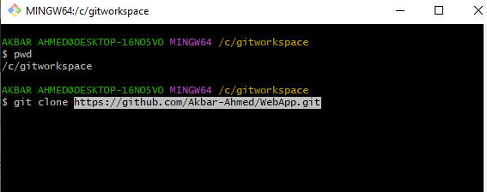

1. Create Jobs according to the requirement . I have created 4 jobs .

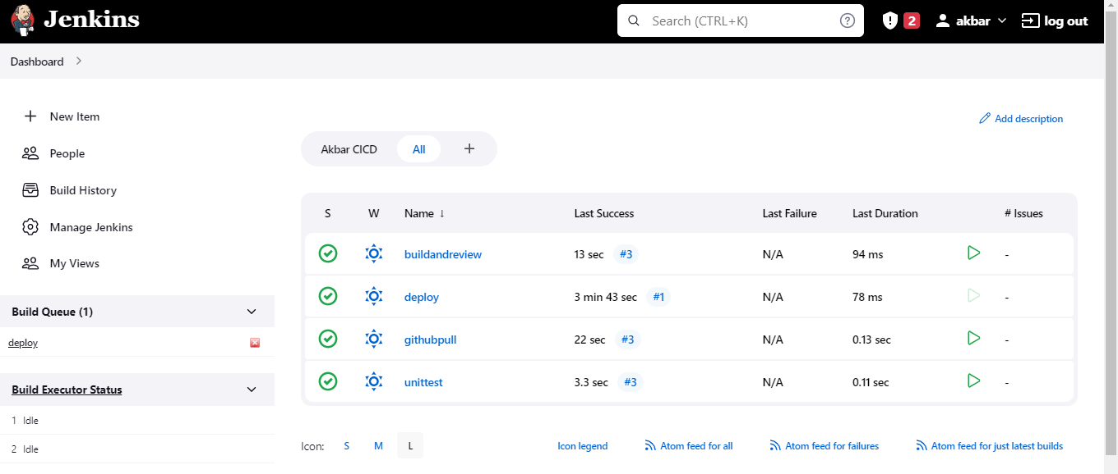

1. For the Jobs to execute successfully , we need to install required plugins.

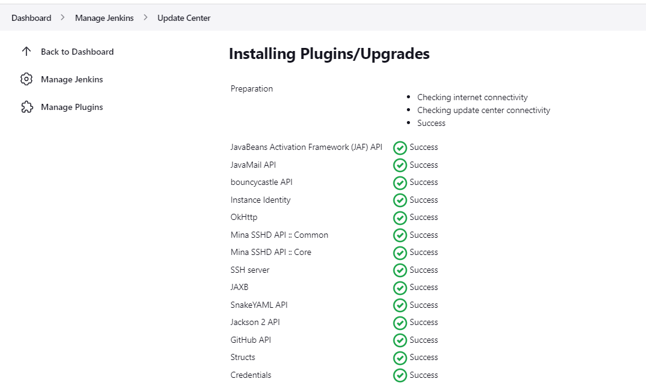

1. In post build actions add the next job which will execute after the current job.
2. Initiate the First job and the pipeline will run automatically.

